

CP Lab-13 Tasks

Name: Syed Muhammad Raza Ali

Enrolment: 02-134231-028

Course: CP Lab

Faculty: Miss Fatima

**Lab 13 Filing**

**Tasks: 01**

Write a C++ that perform following task:

* Create a function Student() that prompt user to a student record. Student contains following details. ID, Full Name, Email, Department and Phone Number.
* Store the input in file student.txt in a proper format.
* In main program call function Student()
* Program should prompt user that you want to enter a new record. If ‘Y’ ask user for new details. If ‘N’, program should terminate. (Use event controlled loop)
* Print the data into the screen.
* Also read from file.

Code:

#include <iOStream>

#include <string>

#include <fstream>

using namespace std;

struct input {

int id,number;

string fullName, email, department;

}obj;

void student() {

char choice;

do {

//Details input

cout << "Enter the details of the student" << endl

<< "=====================================" << endl;

cout << "Enter Student ID" << endl;

cin >> obj.id;

cout << "Enter Fullname of the student" << endl;

cin.ignore();

getline(cin, obj.fullName);

cout << "Enter the email of the student " << endl;

cin >> obj.email;

cout << "Enter the Deparment of the student" << endl;

cin >> obj.department;

cout << "Enter the phone number of the student" << endl;

cin >> obj.number;

//storing data in file

ofstream studentData;

studentData.open("Student Data.txt");

studentData <<"====================================="<<endl

<<"Details of the student" << endl

<<"====================================="<<endl

<< "ID: " << obj.id<<endl

<< "Full name: " << obj.fullName<<endl

<< "E-mail: " << obj.email<<endl

<< "Department: " << obj.department<<endl

<< "Phone number: " << obj.number<<endl

<< "====================================="<<endl;

studentData.close();

//Printing the details on console

cout << "=====================================" << endl

<< "Details of the student" << endl

<< "=====================================" << endl

<< "ID: " << obj.id << endl

<< "Full name: " << obj.fullName << endl

<< "E-mail: " << obj.email << endl

<< "Department: " << obj.department << endl

<< "Phone number: " << obj.number << endl

<< "=====================================" << endl;

cout << "Do you want to enter a new record? " << endl

<<"Press Y for yes and N for no"<<endl;

cin >> choice;

} while (choice == 'y' || choice == 'Y');

}

int main() {

student();

return 0;

}

Output (On console):

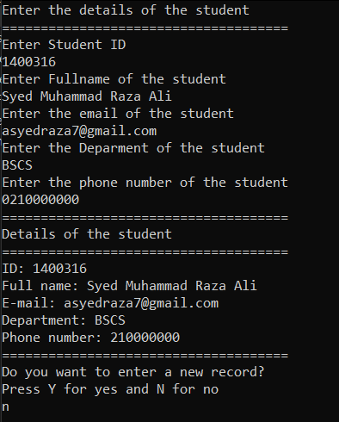

Output (in file):

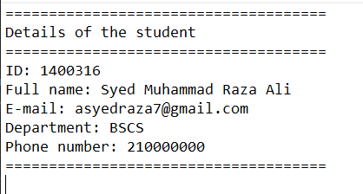

**Tasks: 02**

Write a program which takes input of students (name, grade and marks) and stores it in a text file. The program will then ask a number from the user (between 0 to 50) and increments it in each student’s grade in the file and displays it.

Code:

#include <iostream>

#include <fstream>

#include <string>

using namespace std;

struct Student {

string name;

string grade;

int marks;

};

string GetGrade(int marks) {

if (marks >= 90)

return "A";

else if (marks >= 80)

return "B";

else if (marks >= 70)

return "C";

else if (marks >= 60)

return "D";

else if (marks >= 50)

return "E";

else

return "F";

}

void PromptStudentData(Student& student) {

cout << "Enter Name: ";

getline(cin, student.name);

cout << "Enter Marks: ";

cin >> student.marks;

cin.ignore();

student.grade = GetGrade(student.marks);

}

void StoreStudentData(const Student& student) {

ofstream file("students.txt", ios::app);

if (file.is_open()) {

file << "Name: " << student.name << endl;

file << "Marks: " << student.marks << endl;

file << "Grade: " << student.grade << endl;

file << endl;

file.close();

}

else {

cout << "Unable to open the file." << endl;

}

}

void UpdateGrades(int increment) {

ifstream inputFile("students.txt");

ofstream outputFile("updated_students.txt");

if (inputFile.is_open() && outputFile.is_open()) {

string line;

while (getline(inputFile, line)) {

if (line.find("Marks: ") != string::npos) {

int marks = stoi(line.substr(7));

marks += increment;

outputFile << "Marks: " << marks << endl;

outputFile << "Grade: " << GetGrade(marks) << endl;

}

else {

outputFile << line << endl;

}

}

inputFile.close();

outputFile.close();

remove("students.txt");

rename("updated_students.txt", "students.txt");

}

else {

cout << "Unable to open the file." << endl;

}

}

void DisplayStudentData() {

ifstream file("students.txt");

if (file.is_open()) {

string line;

while (getline(file, line)) {

cout << line << endl;

}

file.close();

}

else {

cout << "Unable to open the file." << endl;

}

}

int main() {

char choice;

do {

Student student;

PromptStudentData(student);

StoreStudentData(student);

cout << "Do you want to enter another student? (Y/N): ";

cin >> choice;

cin.ignore();

cout << endl;

} while (choice == 'Y' || choice == 'y');

int increment;

cout << "Enter the number to increment the grades by (0 to 50): ";

cin >> increment;

UpdateGrades(increment);

cout << "Updated Student Data:" << endl;

DisplayStudentData();

system("pause");return 0;}

Output :

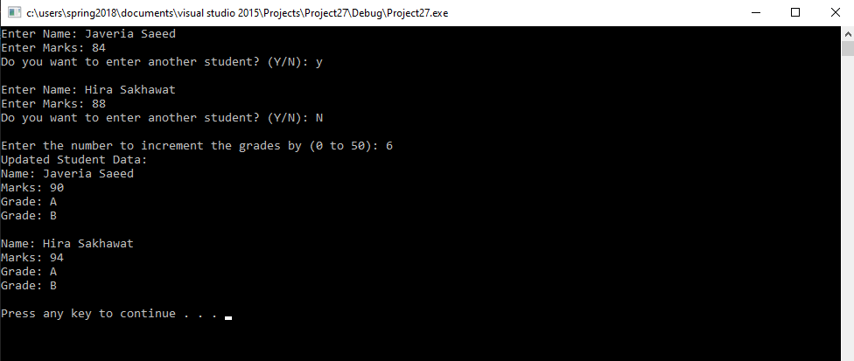

**Tasks: 03**

Write a program which takes a string as an input and stores it a text file. Then it checks if the string is in lowercase, then converts them into upper case. Display the end result in proper format.

Code:

#include <iostream>

#include <fstream>

#include <string>

#include <cctype>

using namespace std;

void StoreStringToFile(const string& text) {

ofstream file("input.txt");

if (file.is_open()) {

file << text;

file.close();

}

else {

cout << "Unable to open the file." << endl;

}

}

void ConvertToLowercase(ifstream& file) {

ofstream outputFile("output.txt");

if (outputFile.is_open()) {

string line;

while (getline(file, line)) {

for (char& c : line) {

if (islower(c)) {

c = toupper(c);

}

}

outputFile << line << endl;

}

outputFile.close();

}

else {

cout << "Unable to open the output file." << endl;

}

}

void DisplayOutput() {

ifstream file("output.txt");

if (file.is_open()) {

string line;

while (getline(file, line)) {

cout << line << endl;

}

file.close();

}

else {

cout << "Unable to open the file." << endl;

}

}

int main() {

string input;

cout << "Enter a string: ";

getline(cin, input);

StoreStringToFile(input);

ifstream inputFile("input.txt");

if (inputFile.is_open()) {

ConvertToLowercase(inputFile);

inputFile.close();

}

else {

cout << "Unable to open the input file." << endl;

return 1;

}

cout << "Resulting text in uppercase: " << endl;

DisplayOutput();

system("pause");

return 0;

}

Output:

